Metallic Bonding | Ionic Structure | Simple covalent structure
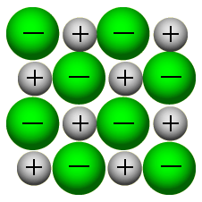 | 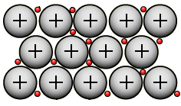 | 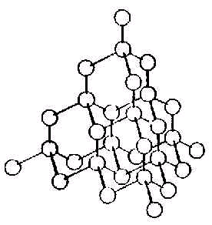
Positive ions surrounded by a ‘sea’ of delocalised electrons | Regular 3D arrangement of positive and negative ions | Isolated molecules with weak forces between molecules
Strong attraction between ions and delocalised electrons | Strong electrostatic attraction between positive and negative ions | Strong bonds between atoms, electrons are shared
High melting points, almost all are solids at room temp | High melting points, always solid at room temp | Low melting points, gases and liquids at room temp
Conduct electricity | Don’t conduct electricity | Diamond
Most don’t conduct electricity (except graphite) | Conduct electricity when molten and in solution | Regular crystal arrangement
Sodium chloride | Iodine | Sodium
Metallic Bonding | Ionic Compound | Simple covalent structure
Positive ions surrounded by a ‘sea’ of delocalised electrons | Regular 3D arrangement of positive and negative ions | Isolated molecules with weak forces between molecules
Strong attraction between ions and delocalised electrons | Strong electrostatic attraction between positive and negative ions | Strong bonds between atoms, electrons are shared
High melting points, almost all are solids at room temp | High melting points, always solid at room temp | Low melting points, gases and liquids at room temp
Conduct electricity | Don’t conduct electricity | Conduct heat
Malleable | Conduct electricity when molten and in solution | Regular crystal arrangement
Sodium chloride | Iodine | Sodium

